

Ref: RB/CD/SHH/19/02 Date: 13th March, 2018

ATTN:
VERONICA STERLEY
6408310022081
South Africa
Loan Amount: 40, 000.00Rand
Account Details: 62020008927. FNB

COLLATERAL DECISION, REQUEST FOR PREPARATION OF LOAN DOCUMENTS

I want to thank you for the opportunity you are giving NEWTON FINANCE to serve you. It is our pleasure having the opportunity to render an assistance regarding the Loan.

After examination of all documents processed, it would be best to collateralize this loan with a physical property worth double of your loan amount paid off in your name. I am confident it will result in a quick acceptance and disbursement of your loan funds.

Therefore, I am instructing you to submit all relevant documents for the collateral to enable us proceed.

Note: If you do not have physical collateral worth double of your loan request which have been approved, the company can proceed with the Non-collateral process which will be done by the company’s lawyer.

Again, I wish to thank you for your cooperation in this matter and am looking forward to the continuance of a long and mutually beneficial relationship between us.

Sincerely,


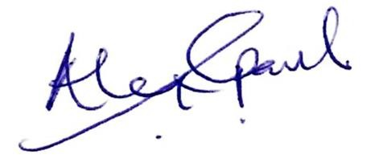

Alex Paul
For: Newton Finance.

